

Submitted By:
Umair Umar CE-25-107
Assignment:
CA Lab No. 2
Submitted To:
Mehmood
For the fulfillment of,
Circuit Analysis Lab
Department of Computer Engineering
University of Engineering and Technology, Lahore

Circuit Analysis — Lab
Simulation Procedure in Proteus
Overview
This document describes the step-by-step procedure followed to simulate Circuit A and Circuit B in Proteus ISIS. A signal generator was used as the AC source, an oscilloscope was added to measure voltages across each resistor, and the output waveforms were recorded using the specified oscilloscope settings.

Part 1: Opening Proteus and Creating a New Project
Step 1: Launch Proteus ISIS from the desktop or Start Menu.
Step 2: Go to File > New Project. Enter a project name (e.g. CA_Lab2) and choose a save location.
Step 3: Select Default Schematic when prompted for the schematic template and click Finish.
Step 4: The schematic editor opens with a blank canvas. This is where the circuit will be built.

Part 2: Adding Components to the Schematic
Step 1: Click the Component Mode button (P) on the left toolbar, or press P to open the Pick Devices library.
Step 2: In the search box, type RES and press Enter. Select RES from the results and click OK to add it to the parts list.
Step 3: Close the Pick Devices window. The resistor will appear in the devices panel on the left side.
Step 4: Click on RES in the devices panel and click on the canvas to place each resistor. Place 2 resistors for Circuit A and 3 resistors for Circuit B.
Step 5: Double-click each placed resistor to open its properties and set the resistance value as required.

Part 3: Adding the Ground Terminal
Step 1: On the left side toolbar, click on the Terminals Mode button (it looks like a small connector pin icon).
Step 2: A list of terminal types will appear on the left panel. Select GROUND from this list.
Step 3: Click on the schematic canvas to place the ground symbol. Position it at the bottom of the circuit, connected to the negative return wire of the circuit.
Step 4: Wire the ground terminal to the bottom node of the circuit (the return path from the last resistor back to the source negative terminal).
Note: The ground terminal establishes the 0V reference point for the entire circuit. All voltage measurements on the oscilloscope are made relative to this ground.

Part 4: Adding the Signal Generator
Step 1: On the left side toolbar, click on the Virtual Instruments Mode button (it looks like an oscilloscope icon).
Step 2: A list of virtual instruments will appear in the left panel. Select SIGNAL GENERATOR from the list.
Step 3: Click on the schematic canvas to place the signal generator. Position it on the left side of the circuit near the input.
Step 4: Wire the output terminal of the signal generator to the top node of the circuit (the positive input, connecting to R1).
Step 5: Wire the ground terminal of the signal generator to the circuit ground.
Step 6: Run the simulation by pressing the Play button at the bottom. The signal generator panel will open.
Step 7: In the signal generator panel, configure the following settings:

Parameter | Circuit A | Circuit B
Waveform | Sine
Frequency | 100 Hz | 200 Hz
Amplitude | 2.5 V (peak) = 5 V p-p | 3.5 V (peak) = 7 V p-p
Offset | 0 V
Note: The amplitude on the signal generator is set as peak voltage (Vp). Peak-to-peak voltage Vpp = 2 x Vp.

Part 5: Adding the Oscilloscope
Step 1: Stop the simulation if it is running.
Step 2: From the Virtual Instruments Mode panel on the left, select OSCILLOSCOPE.
Step 3: Place the oscilloscope on the schematic canvas.
Step 4: Connect Channel A (CH A) probe to the input node — the junction between the signal generator output and R1. This channel will display the input voltage.
Step 5: Connect Channel B (CH B) probe to the node across the resistor being measured.
Step 6: Connect the oscilloscope ground to the circuit ground terminal.
Note: To measure the voltage across a specific resistor, place the CH B probe on one side of that resistor. The oscilloscope ground (already connected to circuit ground) acts as the other reference point.

Part 6: Configuring Oscilloscope Settings
Step 1: Run the simulation by pressing the Play button. The oscilloscope window will open.
Step 2: Set the vertical (voltage) scale for each channel using the V/DIV control:

Signal | V/div Setting
Input voltage (CH A) | 0.5 V/div
Voltage across any resistor (CH B) | 0.2 V/div

Step 3: Set the horizontal (time) scale using the TIME/DIV control:
Time/div = 10 ms/div (same setting used for both Circuit A and Circuit B)
Step 4: Adjust the trigger if the waveform is not stable. Set trigger source to CH A and mode to Auto.
Step 5: The waveform should now appear stable and centred on screen.

Part 7: Circuit A Simulation and Results
Circuit Specifications
R1 | 5.1 kO
R2 | 3.3 kO
Connection | Series
Signal generator output | 5 V p-p, Sine wave
Frequency | 100 Hz
Period | T = 1/100 = 10 ms

Simulation Steps
Step 1: Place R1 (5.1 kO) and R2 (3.3 kO) in series on the schematic.
Step 2: Connect the signal generator with frequency = 100 Hz and amplitude = 2.5 V (peak).
Step 3: Add a ground terminal from the left side Terminals Mode panel and connect it to the bottom node of the circuit.
Step 4: Connect CH A of the oscilloscope to the input node to monitor the source signal.
Step 5: Connect CH B across R1. Run the simulation and note the waveform amplitude and period.
Step 6: Stop the simulation. Move CH B across R2. Run again and record the waveform.
Step 7: Record all voltage readings in the data table below.

Measured Values
Resistor | Input Voltage | RMS Voltage | P-P Voltage
R1 | 5 V | 1.07 V | 3.04 V
R2 | 5 V | 0.695 V | 1.96 V

Oscilloscope Output Circuit A
The following waveforms were observed on the oscilloscope. Time/div = 10 ms/div. One complete cycle (T = 10 ms) fits within exactly 1 horizontal division.

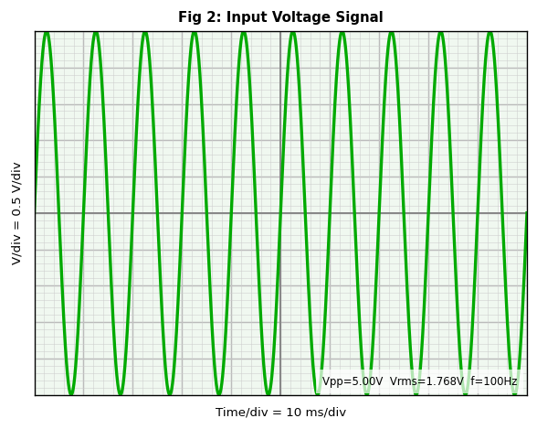  Input Voltage — 5V p-p, 100 Hz (V/div=0.5, Time/div=10ms, 10 boxes p-p) | 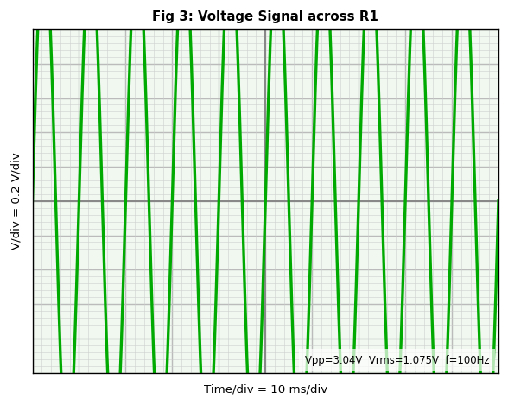  Voltage across R1 — 3.04V p-p (V/div=0.2, Time/div=10ms, ~15.2 boxes p-p)

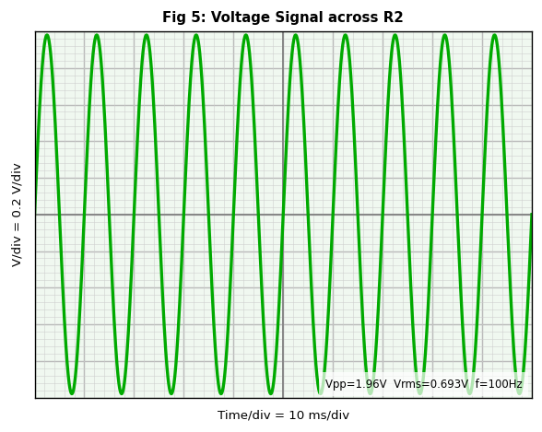  Voltage across R2 — 1.96V p-p (V/div=0.2, Time/div=10ms, ~9.8 boxes p-p) | 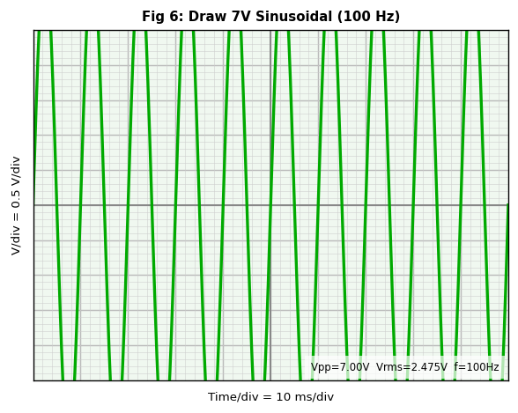  7V Sinusoidal Reference — 100 Hz (V/div=0.5, Time/div=10ms, 14 boxes p-p)

Observation
All waveforms are sinusoidal at 100 Hz with period T = 10 ms. One complete cycle fits in exactly one horizontal division. Since the circuit is purely resistive, there is no phase shift — all waveforms rise and fall at exactly the same time. VR1 + VR2 = 3.04 + 1.96 = 5 V, confirming Kirchhoff's Voltage Law.

Part 8: Circuit B Simulation and Results
Circuit Specifications
R1 | 4.7 kO
R2 | 3.3 kO
R3 | 5.1 kO
Connection | Series
Signal generator output | 7 V p-p, Sine wave
Frequency | 200 Hz
Period | T = 1/200 = 5 ms

Simulation Steps
Step 1: Open a new schematic or clear the existing one.
Step 2: Place R1 (4.7 kO), R2 (3.3 kO), and R3 (5.1 kO) in series on the canvas.
Step 3: Connect the signal generator with frequency = 200 Hz and amplitude = 3.5 V (peak).
Step 4: Add a ground terminal from the left side Terminals Mode panel and connect it to the bottom node of the circuit.
Step 5: Connect CH A of the oscilloscope to the input node.
Step 6: Connect CH B across R1 and run the simulation. Record the waveform.
Step 7: Stop the simulation. Move CH B across R2, run again, and record. Repeat for R3.
Step 8: Move CH B to span across both R1 and R2 together (probe on top of R1, reference at bottom of R2). Record the waveform.
Step 9: Move CH B to span across R2 and R3 together. Record the waveform.
Step 10: Stop the simulation and fill in the data table.

Measured Values
Resistor | Input Voltage | RMS Voltage | P-P Voltage
R1 | 7 V | 0.888 V | 2.51 V
R2 | 7 V | 0.624 V | 1.76 V
R3 | 7 V | 0.964 V | 2.73 V
R1 and R2 | 7 V | 1.511 V | 4.27 V
R2 and R3 | 7 V | 1.588 V | 4.49 V

Oscilloscope Output — Circuit B
Time/div = 10 ms/div. Since T = 5 ms, one complete cycle spans only 0.5 divisions. This means 2 full sine waves are visible per horizontal division on the screen.

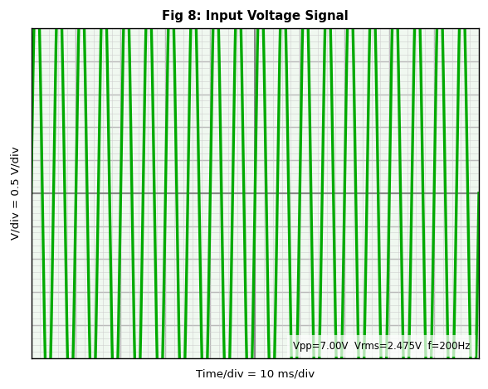  Input Voltage — 7V p-p, 200 Hz (V/div=0.5, Time/div=10ms, 14 boxes p-p, 2 cycles per div) | 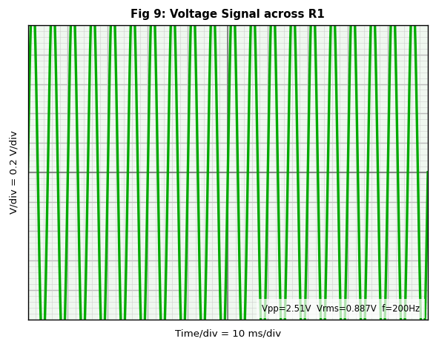  Voltage across R1 — 2.51V p-p (V/div=0.2, Time/div=10ms, ~12.6 boxes p-p)

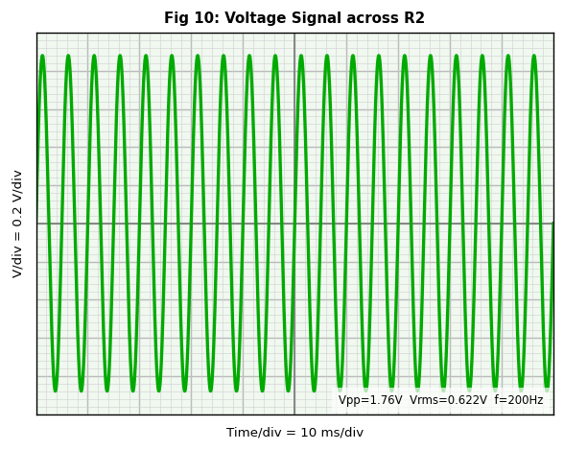  Voltage across R2 — 1.76V p-p (V/div=0.2, Time/div=10ms, ~8.8 boxes p-p) | 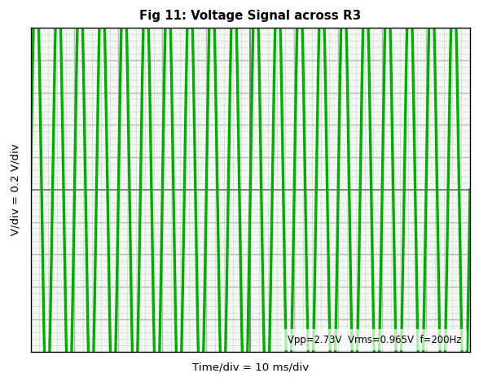  Voltage across R3 — 2.73V p-p (V/div=0.2, Time/div=10ms, ~13.6 boxes p-p)

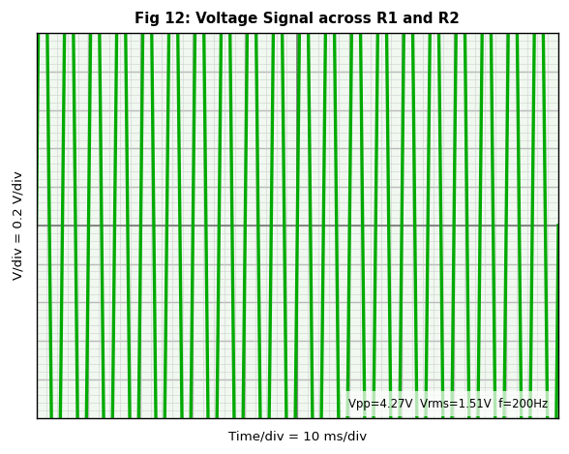  Voltage across R1 and R2 — 4.27V p-p (V/div=0.2, Time/div=10ms, ~21.4 boxes p-p) | 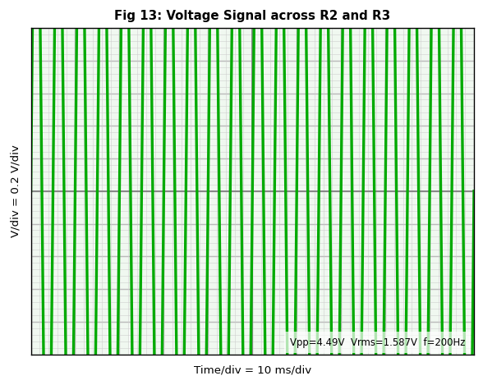  Voltage across R2 and R3 — 4.49V p-p (V/div=0.2, Time/div=10ms, ~22.4 boxes p-p)

Observation
All waveforms are sinusoidal at 200 Hz. With time/div = 10 ms, two complete cycles appear per division. All waveforms are in phase with the input since the circuit is purely resistive. VR1 + VR2 + VR3 = 2.51 + 1.76 + 2.73 = 7 V, confirming Kirchhoff's Voltage Law.

Conclusion
Both circuits were successfully built and simulated in Proteus ISIS using the signal generator as the AC source and the virtual oscilloscope for measurements. Key findings:

1. Voltage divides across series resistors in proportion to their resistance values.
2. Purely resistive circuits produce no phase shift — all waveforms are in sync with the input.
3. The sum of all voltage drops equals the source voltage, confirming Kirchhoff's Voltage Law.
4. At 200 Hz with time/div = 10 ms, two complete cycles appear per division, while at 100 Hz only one cycle appears per division.
5. RMS voltage = Vpp / (2 x sqrt(2)) = 0.3536 x Vpp for any pure sinusoidal signal.

